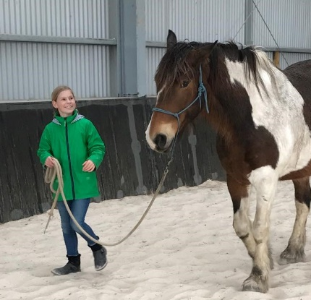
OVERVIEW
CONNECTIONS is a highly effective and innovative 4 or 8 week Equine Experiential Learning program in which participants work alongside Eureka’s horse teachers to develop greater self-awareness, through building life skills including self-confidence, resilience, social skills and communication. Kids aged 8-18 will benefit.
Participants learn about themselves and others by participating in ground based activities with the horses and then discussing feelings, behaviours and patterns. The goal is to assist individuals with learnings around emotional and behavioural matters both in themselves and others and develop awareness of caring for others, compassion and care of self.
CONNECTIONS uses both small group and individual tasks, resulting in enhanced learning, insight and personal development. Participants become more authentic, congruent and self-aware. Debriefing helps participants link their learnings back to their daily lives and put them into practice.
The program is fun yet challenging; an engaging experience where individuals feel safe, valued and able to be their authentic selves.

WEEK 1 : BUILDING FRIENDSHIPS / RELATIONSHIPS
WEEK 2 : SKILLS DEVELOPMENT, LEADERSHIP
WEEK 3 : BOUNDARIES, ASSERTIVENESS
WEEK 4 : COMMUNICATION & TEAM SKILLS
WEEK 5 : FOCUS, ACTIVE LISTENING
WEEK 6 : BODY LANGUAGE, SILENT COMMUNICATION
WEEK 7 : TRUST, RESPONSIBILITY
WEEK 8 : PROBLEM SOLVING, NEGOTIATION
  - WHY HORSES?
Horses are sensitive and forgiving. They don’t lie and they provide us with immediate, honest and non-judgemental feedback. They require trust, respect, congruency and clear communication, and teach us how to create a willing partnership rather than one based on force. They also assist us in becoming more aware and mindful, which includes being calm while offering clear, confident communication. They teach us about boundaries – both ours and those of others, help demonstrate the power of thought and intention, and also install empathy and kindness.
COSTS $100 / week / participant (includes GST)
DURATION 4 and 8 week programs available

*** We take a maximum of 4 participants/program. Contact us now to ensure a place for your child ***

